LOAD FREQUENCY CONTROLLER DESIGN USING NEURAL NETWORKS

Hassan Bevrani

West Regional Electric CO.
Research & Standards office
P.O. Box 67144
Kermanshah, Iran
Fax: +98-832653
Abstract

In this Paper, we design and introduce of a load frequency controller for typ ical power system in competitive, distributed control environment with open access organizational structure. With this new structure, coms the need for novel control strategies to maintain the reliability and eliminates the frequency error, and conventional controllers are incapable of obtaining good dynamical performance.
The paper will demonstrate neural networks application to automatic Load Frequency Control (LFC) in a deregulated electric power system environment. A sample power system is used to illustrate the design method.

1 Introduction
Any power system has a fundamental control problem of matching real power generation to load plus losses, a problem called Load Frequency Control (LFC) or frequency regulation. The purpose of Load Frequency Control is tracking of load variation while maintaining system frequency and tie line power interchanges close to specified values. Reference [1], give a detailed discussion of LFC. In this paper, we consider the system as an area, that include separate generation transmission and distribution companies with an open access policy. In this new structure, each control area has its own generation and transmission network, and distribution company is responsible for tracking its own load and honoring tie-line power exchange contracts with its neighbors by securing as much transmission and generation capacity as needed.
Under current organizations, several notable approches based on classical, optimal, H∞, μ- synthesis and other control theorems have already been proposed [2-11], [12]. discusses several LFC scenarios and issues in power system operation after deregulation.
This paper presents a possible solution to LFC problem with new structure by introducing a Neural Network Controller (NNC) which ensures that selected generators will automatically follow load changes in the area. Following this introduction, the second section gives a description of the model used for the simulations in this work. The third section demonstrates the design of load frequency controller, and simulation results are presented in section 4.

2 Dynamical Model
Based on the new structure, let us consider a simple distribution company and its suppliers as shown in Figure 1, [8-9] In this example the distribution company (DISCO) buys firm power from one generation company ( GENCO 2) and enough power from other generation company (GENCO 1) to supply its load and support the LFC task. Transmission company (TRANSCO 1) delivers power from GENCO 1. TRANSCO 1 is also contracted to deliver power associated with the LFC problem.
In the structure proposed the DISCO are to be responsible for tracking the load and hence performing the load frequency control task by securing as much transmission and generation capacity as needed. Connections of the DISCO to other companies are considered as disturbances.
For simplicity assume that GENCO_{S} 1 and 2 have one generator each. The linearized dynamics of the generators are given by :

$$\frac{2H_{1}}{f_{O}}\frac{{dΔf}_{1}}{\text{dt}}={ΔP}_{\text{MI}}−d_{1}−D_{1}{Δf}_{1}$$
$$\frac{2H_{2}}{f_{O}}\frac{{dΔf}_{2}}{\text{dt}}={ΔP}_{M2}−{ΔP}_{2}−d_{2}−D_{2}{Δf}_{2}$$
$$\frac{{dΔδ}_{i}}{\text{dt}}=2{πΔf}_{i}$$

Where Δ : deviation from nominal value
H_{i} : constant of inertia
D_{i} : Damping
f_{O} : nominal frequency
f_{i} : frequency
δ_{i} : rotor angle
P_{M} : turbine (mechanical) power
d_{i} : disturbance (power quantity).

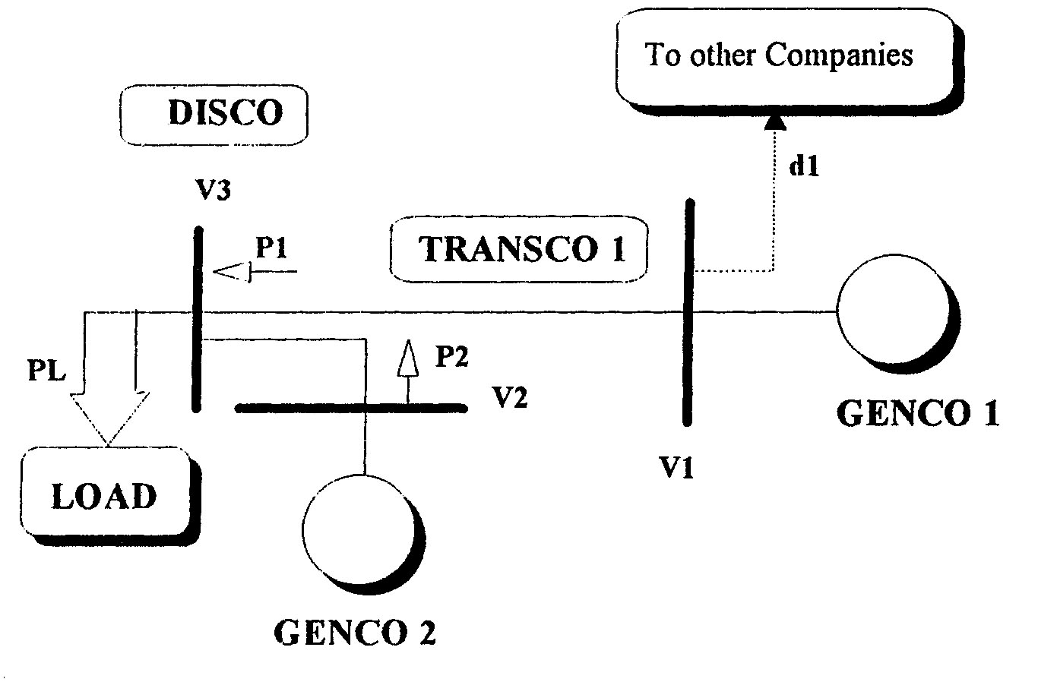

Figure 1: A distribution company and its suppliers

The generators are equipped with a speed governor. The simplest models of speed governors
and turbines associated with generator i are given by:

$$\frac{{dΔP}_{\text{Vi}}}{\text{dt}}=−\frac{1}{T_{\text{Hi}}}{ΔP}_{\text{Vi}}+\frac{K_{\text{Hi}}}{T_{\text{Hi}}}({ΔP}_{\text{refi}}−\frac{1}{R_{i}}{Δf}_{i})$$
(2)
$\frac{{dΔP}_{\text{Mi}}}{d}=−\frac{1}{T_{\text{Mi}}}{ΔP}_{\text{Mi}}+\frac{K_{\text{Mi}}}{T_{\text{Mi}}}{ΔP}_{\text{Vi}}$
Where P_{v} : steam valve power
T_{M} and T_{H} : time constants of turbine and governor
K_{M} and k_{H} : gains of turbine and governor
R_{i} : droop characterisict
P_{refi} : reference setpoint (control input)
The power flows from the GENCOs to the DISCO are expressed in trems of the voltages and line reactances. Let V_{i} = |V_{i}|∠δ_{i} be the voltage at bus i. Then:

${ΔP}_{1}=T_{1}({Δδ}_{1}−{Δδ}_{3})$ (3)
${ΔP}_{2}=T_{2}({Δδ}_{2}−{Δδ}_{3})=−T_{2}({Δδ}_{1}−{Δδ}_{2})+T_{2}({Δδ}_{1}−{Δδ}_{3})$ (4)
$\text{where}:T_{i}=\frac{\left|V_{i}\right|\left|V_{3}\right|\text{cos}(δ_{i^{0}}−δ_{3^{0}})}{X_{i}}$ (5)
T_{i} is synchronizing power coefficient of line i connected to the DISCO (bus 3) via a line whose reactance is x_{i} .
The change in load is expressed by:

${ΔP}_{L}={ΔP}_{1}+{ΔP}_{2}=(T_{1}+T_{2})({Δδ}_{1}\text{- }{Δδ}_{3}){\text{-T}}_{2}({Δδ}_{1}−{Δδ}_{2}) (\text{6 })$(Δδ₁ - Δδ₃) is eliminated from equation (3) and (4) using equation (6):
$({Δδ}_{1}−{Δδ}_{3})=\frac{T_{1}}{(T_{1}+T_{2)}}{ΔP}_{L}+\frac{T_{1}T_{2}}{(T_{1+}T_{2})}({Δδ}_{1}−{Δδ}_{2})$ (7)
Therefore, the state space model of the distribution area is given by:
x = Ax + Bu + Dw
where: (8)
x^{T} = [Δf₁ ΔP_{MI} ΔP_{VI} Δδ₁-Δδ₂ Δf₂ ΔP_{M2} ΔP_{V2}]

w^{T} = [ΔP_{L} d₁]; u = ΔP_{ref1}
$$A=\begin{aligned}\left[\begin{matrix}−\frac{D_{1}}{T_{P1}} & \frac{1}{T_{P1}} & 0 & −\frac{α}{T_{P1}} & 0 & 0 & 0 \\ 0 & −\frac{1}{T_{M1}} & \frac{K_{M1}}{T_{M1}} & 0 & 0 & 0 & 0 \\ −\frac{K_{H1}}{R_{1}T_{H1}} & 0 & −\frac{1}{T_{H1}} & 0 & 0 & 0 & 0 \\ 2π & 0 & 0 & 0 & −2π & 0 & 0 \\ 0 & 0 & 0 & \frac{α}{T_{P2}} & −\frac{D_{2}}{T_{P2}} & \frac{1}{T_{P2}} & 0 \\ 0 & 0 & 0 & 0 & 0 & −\frac{1}{T_{M2}} & \frac{K_{M2}}{T_{M2}} \\ 0 & 0 & 0 & 0 & −\frac{K_{H2}}{R_{2}T_{H2}} & 0 & \begin{aligned}−\frac{1}{T_{H2}} \\ \end{aligned}\end{matrix} | \right] \\ \end{aligned}$$

$α=\frac{T_{1}T_{2}}{(T_{1}+T_{2})},T_{\text{Pi}}=\frac{2H_{i}}{f_{0}}$

$$B^{T}=\left[\begin{matrix}0 & 0 & \frac{K_{m}}{T_{m}} & 0 & 0 & 0 & 0\end{matrix}\right]$$
$$\begin{aligned} \\ D^{T}=\left[\begin{matrix}−\frac{T_{1}}{(T_{1}+T_{2})T_{P1}} & 0 & 0 & 0 & −\frac{T_{2}}{(T_{1}+T_{2})T_{P2}} & 0 & 0 \\ −\frac{1}{T_{P1}} & 0 & 0 & 0 & 0 & 0 & 0\end{matrix}\right]\end{aligned}$$

As an example, consider a distribution company as depicted in figure 3. Data is given in
Table 1, [8].

Table 1 : Data for the simulation
Quantity | GENCO 1 | GENCO 2
Rating (MW) | 1000 | 800
Constant of Inertia : H(sec) | 5 | 5
Damping: D (pu MW/Hz) | 0.02 | 0.015
Droop characteristic: R (%) | 4 | 5
Generator's: T_{p}= 2H/f₀ | 0.2 | 0.2
Turbine's Time Constant: T_{M} | 0.5 | 0.5
Governor's Time Constant: T_{H} | 0.2 | 0.1
Gains: K_{M}, K_{H} | 1 | 1
Synchronizing coefficients: T_{i} | 0.2 | 0.1

3 Load Frequency Controller
The state-space model is based equation (8), however it is augmented to include the rotor angle of GENCO 1 since one of objectives of LFC problem is to guarantee that the frequency will return to its nominal value following a step disturbance. Hence, the state vector becomes:

x^{T} = [Δf₁ ΔP_{M1} ΔP_{V1} Δδ₁-Δδ₂ Δf₂ ΔP_{M2} ΔP_{V2} Δδ₁] (9)

The augmented system has the following state-space model:
$$\overset{˙}{x}=\bar{A}\text{x }+\bar{B}u+\bar{D}w$$

(10)
where:
$$\overline{A}=\begin{aligned}\left[{\text{AO}}_{7×1} | \right] \\ \end{aligned}$$

Let the output variables be given by the Distribution Company Error (DCE) and its integral. DCE is defined in this paper analogously to the traditional ACE (Area Control Error) by:

DCE=ΔP₁+ ΔP₂+β₁Δf₁ + β₂Δf₂

(11)
where $β_{i}=D_{i}+\frac{1}{R_{i}}$ is the frequency response characteristic of unit i. Therefore, the output variables are given by:
y = Cx + Gw

(12)
Where:
C = [β₁ 0 0 1 β₂ 0 0 1]; G = [1 0].

We now proceed to design a load frequency controller using the neural networks. Reference [12], give a detailed discussion of neural networks. The block diagram of Neural Network Controller (NNC) and power system as a plant, is shown in fig . 2.
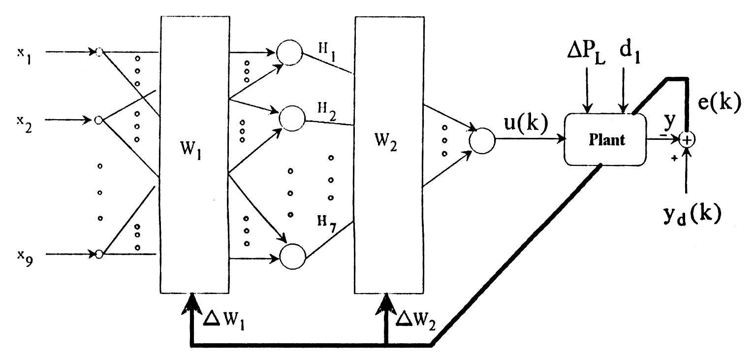

Fig. 2: The block diagram of NNC and plant
As shown in fig 2. we use the direct control scheme. A 3-layer neural network is formed by sets of nodes connected together. The neural network acts as a feed forward controller to supply the plant a correct driving input u(k), which is based on the reference input signal y_{d} (k), previous plant output signals y(k), y(k-1), …., y(k-4) and control output signals u(k), u(k-1), …, u(k-3). y_{d}(k), is the output variable y(k) when ACE must be equal to zero. Then the input vector of neural network is:
X^{T} = [x₁, x₂,…, x₉] = [y_{d} (k), y (k-1),…., y (k – 4), u(k), u(k – 1),…, u (k -3)]
H₁, …. H₇ are outputs of hidden-layer, u(k) is the output of the output-layer. As shown in above figure, the system (plant) can be controlled by using only three layers. Simulation results show that increasing the number of layer dos not significantly improve the control performance. For the problem at hand, the neural network consists of 9 linear functions in the input-layer, 7 bipolar sigmoid function in the hidden-layer and one unipolar sigmoid function in the output-layer, with the following relations :
Bipolar sigmoid functions $f_{1}(x)=\frac{k_{1}(1−e^{−x})}{(1+e^{−x})}$ (13)
Unipolar sigmoid functions $f_{2}(x)=\frac{k_{2}}{(1+e^{−x})}$ (14)
where, for this example : k₁ = 1 , k₂ = 0.1
When the NNC is native, i. e. the network is with random initial weights, an erroneous plant input u(k) may be produced erroneous output y(k). This output will then be compared with the reference signal y_{d}(k). The resulting error signal e(k) is used to train the weights in the network using the back-propagation algorithm. With repetitive training, the network will learn how to response correctly to the reference signal input.
As shown in fig 2, we use the direct control scheme. A 3-layer neural network is formed by sets of nodes connected together. The neural network acts as a feed forward controller to supply the plant a correct driving input u (k), which is based on the reference input signal y_{d} (k), previous plant output signals y(k), y(k-1), …., y(k-4) and control output signals u(k), u(k-1),…., y(k-4) and control output signals u(k), y(k-1), … u(k-3) y_{d} (k). is the output variable y(k) when ACE must be equal to zero. Then the input vector of neural network is :

X^{T} = [x₁ , x₂, …, x₉] = [y_{d} (k), y (k – 1), …, y (k - 4), u (k), u (k - 1), …, u (k -3)]

H₁, … H₇ are outputs of hidden-layer, u(k) is the output of the output-layer. As shown in above figure, the system (plant) can be controlled by using only three layers. Simulation results show that increasing the number of layers dos not significantly improve the control performance. For the problem at hand, the neural network consists of 9 linear functions in the input-layer, 7 bipolar sigmoid function in the hidden-layer and one unipolar sigmoid function in the output-layer, with the following relations :

Bipolar sigmoid functions $f_{1}(x)=\frac{k_{1}(1−e^{−x})}{(1+e^{−x})}$ (13)
Unipolar sigmoid functions $f_{2}(x)=\frac{k_{2}}{(1+e^{−x})}$ (14)
where, for this example : k₁ = 1 , k₂ = 0.1.

When the NNC is native, i. e. the network is with random initial weights, an erroneous plant input u(k) may be produced erroneous output y(k). This output will then be compared with the reference signal y_{d} (k). The resulting error signal e(k) is used to train the weights in the network using the back – propagation algorithm. With repetitive training, the network will learn how to response correctly to the reference signal input.
As the number of training increases, the network is becoming more and more mature, hence the plant output error would be smaller and smaller.
However, back-propagation of error singnal can not be directly used to train the NNC. In order to properly adjust the weights of the network using the back-propagation algorithm, the error in the NCC output ∈(k) = u_{d} (k) – u (k), where u_{d} (k) is the desired driving input to the plant, should be known. Since only the plant output error e(k) = y_{d} (k) – y (k) is measurable or available, ∈(k) can only be determined using the following expression :

$∈(k)=e(k)\frac{∂y(k)}{∂u(k)}$ (15)
Where the partial derivative is the jacobian of the plant. Thus, the application of this scheme requires a through knowledge of the jacobian of the plant. For simplicity, insist of (15), we use:

(16)$∈(k)=e(k)\frac{Δy(k)−Δy(k−1)}{Δu(k)−Δu(k−1)}$

4 Simulation Results
The figures below show the simulation results following a 10% load increase in the distribution system. Figure 3 show the Area Control Error (ACE) signal and figure 4 and 5 compare the closed-loop and open-loop frequency deviations at both GENCOs. At steady-state the frequency is back to its nominal value. These figures demonstrate the effectiveness of the proposed design.
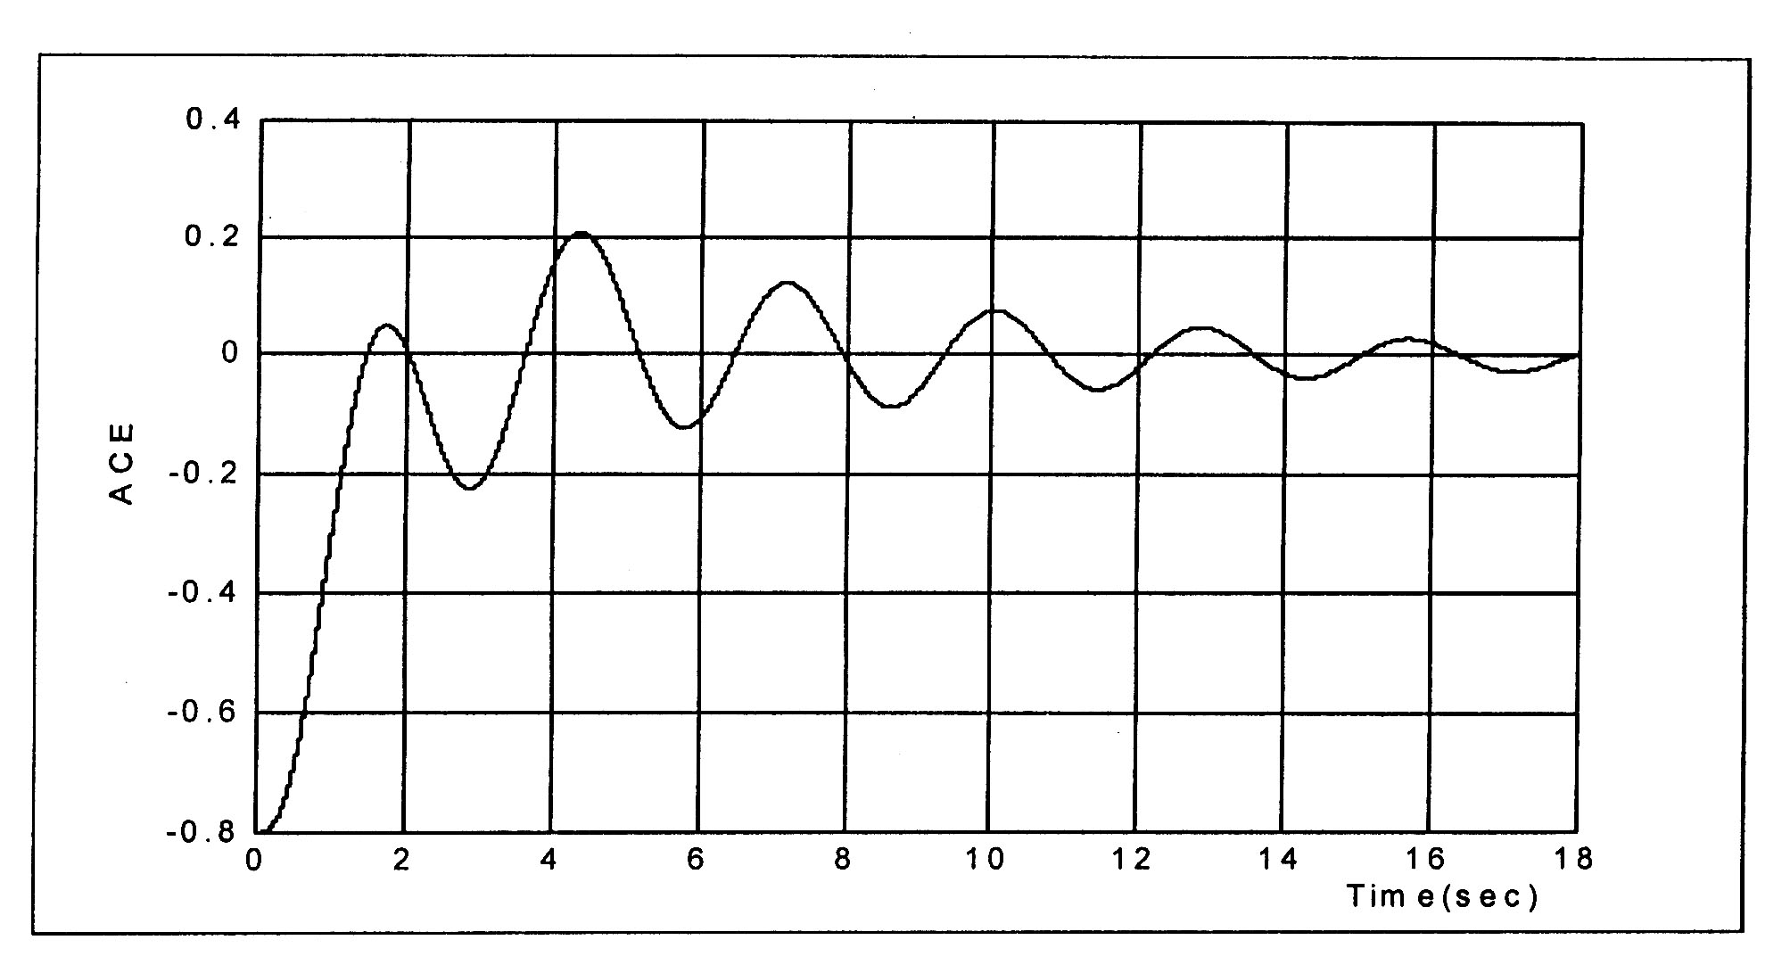
Fig. 3 : The Area Control Error (ACE) signal

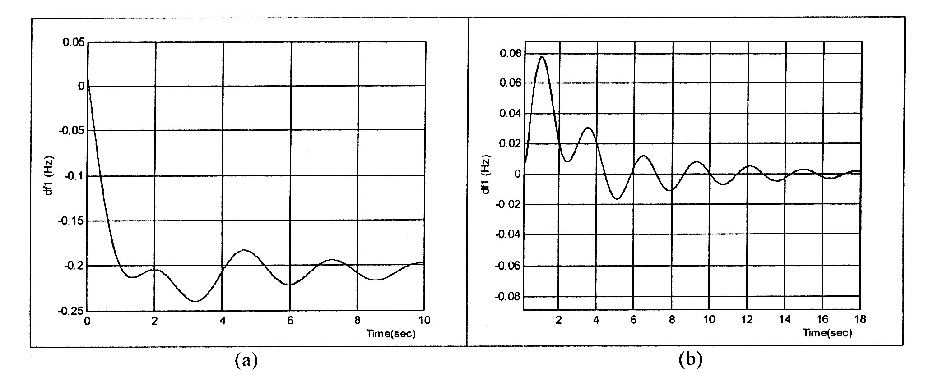
Figure 4 : Frequency deviation GENCO 1 following a 10% load increase,
(a) Open-loop system; (b) Closed-loop system

Simulation results show that Changes in power coming to the distribution company from GENCO 1 and GENCO 2, shows that power is Initially coming from both units to respond to the load increase which will result in a frequency drop that is sensed by the speed governors of both machines. But at steady-state the additional power is coming from GENCO 1 only and GENCO 2 does not contribute to the LFC problem solution.

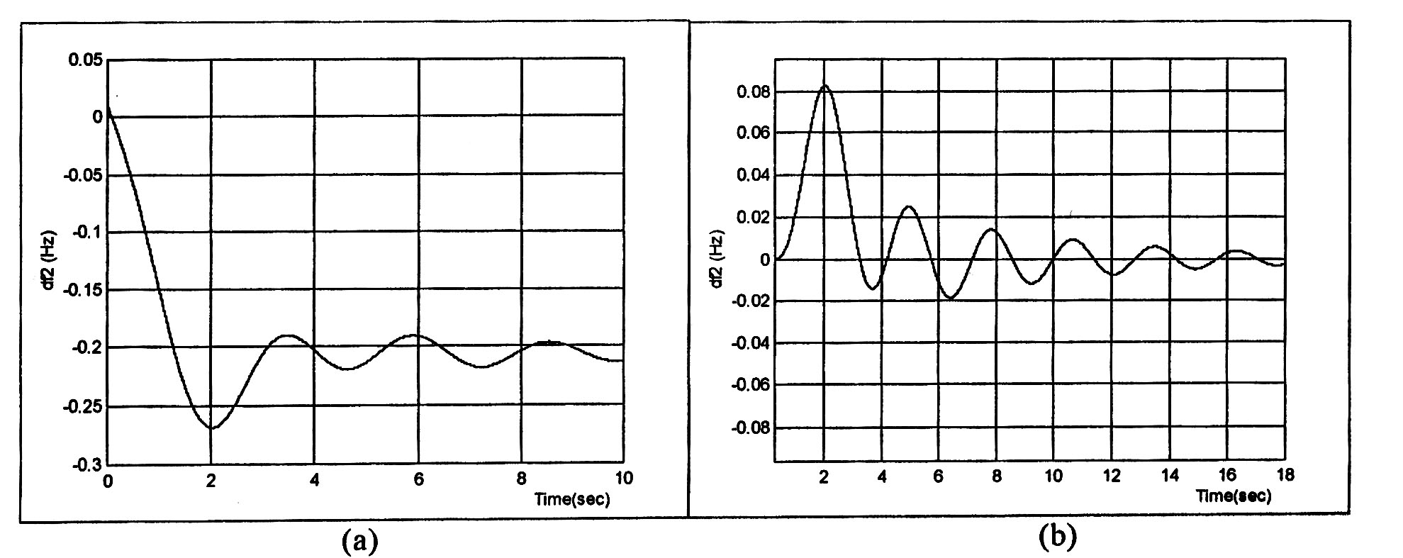
Figure 5 : Frequency deviation at GENCO 2 following a 10% load increase,
(a) Open-loop system; (b) Closed-loop system
5 Conclusion
An approach to load frequency controller for electric power system for a possible structure in a deregulated environment is proposed using the neural networks. The system is modeled as a
collection of independent distribution companies supplied by generation companies either directly or trough transmission companies. The distribution companies are responsible for tracking the load and hence they are in charge or the Load Frequency Control problem. Connections between distribution companies and the rest of the system taken as disturbances. The methodology presented here can be extended to larger size systems.
A simple test system is given to demonstrate the effectiveness of the proposed approach.
Based on extensive simulation results, it is verified that all proposed design objectives are met.

References
[1] N. Cohn, "Control of Generation and Power Flow on Interconnected Power Systems," New
York: John Wiley & Sons, 1961.
[2] E. J. Davison, N. K. Tripathi, "The Optimal Decentralized Control of a Large Power System: Frequency Control," IEE Trans. Autom. Control, Vol, AC-23, 1978.
[3] M. S. Calovic, "Automatic Generaltion Control: Decentralized Area-Wise Optimal Solution," Electric Power Systems Research, Vol. 7, 1984.
[4] Y. M. Park, K. L. Lee, "Optimal Decentralized Load Frequency Control." Electric Power Systems Research, Vol. 7, 1984.
[5] A. Feliachi, "Optimal Decentralized Load Frequency Control," IEEE Trans. on Power Systems, Vol. PWRS-2, No. 2, 1987.
[6] C. M. Liaw and K. H. Chao, "on the Design of an Optimal Automatic Generation Controller for Interconnected Power System," Int. J. Contr., Vol. 58, 1993.
[7] T. C. Yang, H. Cimen and Z. T. Ding, "A New Robust Decentralized Power System Load Frequency Controller Design Method," Proceedings of ICARCV, Singapore, 1996.
[8] A. Feliachi, "On Load Frequency Control in a Deregulated Environment," IEE Inter. Conf. on Control Applications, 1996.
[9] H. Bevrani, "Robust Load Frequency Control in a Deregulated Environment:" IEEE Conf. on Control Applications, USA, 1999.
[10] B. H. Bakken and O. S. Grande, "Automatic Generation Control in a Deregulated Power System," IEEE Tras. On Power Systems, Vol. 13, No. 4, Nov. 1998.
[11] A. M. Stankovic, G. Tadmor and T. A. Sakharuk," On Robust Control Analysis and Design for Load Frequency Regulation, "IEEE Tras. On Power Systems, Vol. 13, No. 2, May 1998.
[11] R. D. Christie, A. Bose, "Load Frequency Control Issues in Power System Operation after Deregulation," Proceedings of CCA Conference, Dearborn, 1996.

